**Topics: Descriptive Statistics and Probability**

1. Look at the data given below. Plot the data, find the outliers and find out $μ, σ, σ^{2}$

|  |  |
| --- | --- |
| **Name of company** | **Measure X** |
| Allied Signal | 24.23% |
| Bankers Trust | 25.53% |
| General Mills | 25.41% |
| ITT Industries | 24.14% |
| J.P.Morgan & Co. | 29.62% |
| Lehman Brothers | 28.25% |
| Marriott | 25.81% |
| MCI | 24.39% |
| Merrill Lynch | 40.26% |
| Microsoft | 32.95% |
| Morgan Stanley | 91.36% |
| Sun Microsystems | 25.99% |
| Travelers | 39.42% |
| US Airways | 26.71% |
| Warner-Lambert | 35.00% |

**ANS:--**

**Hist:-**

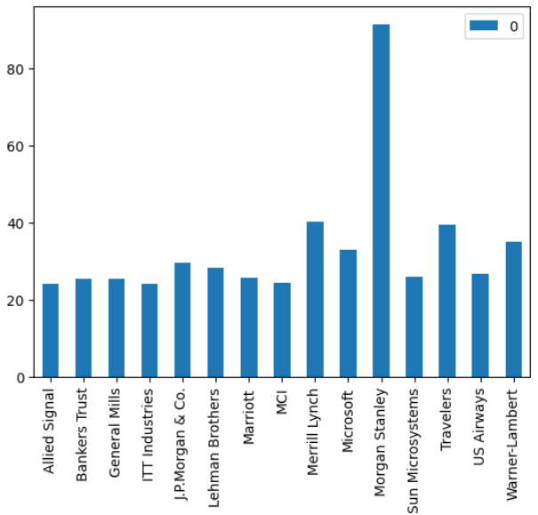

**Boxplot:-**

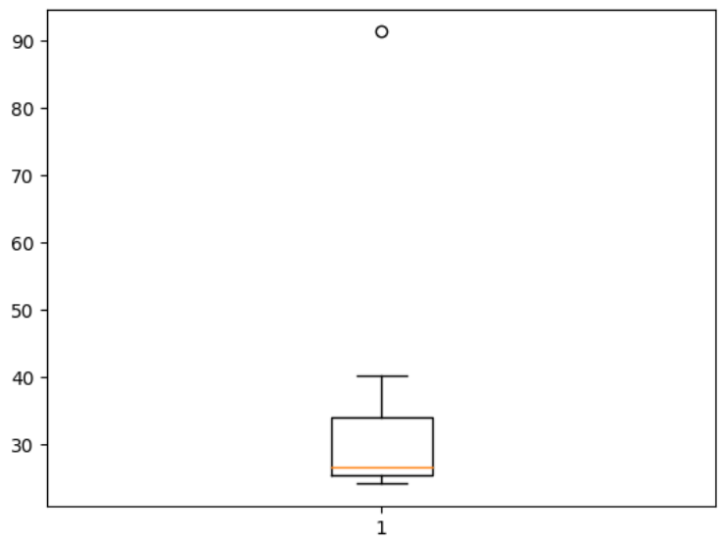**OUTLIER:- The one outlier is at 92.**

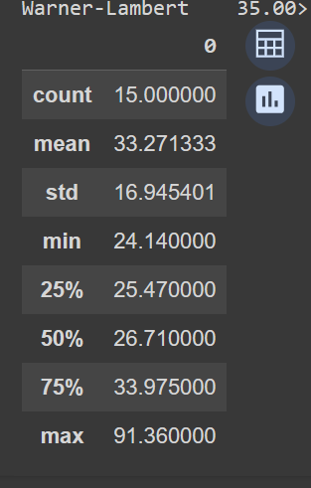

**🡪The values of $μ, σ, σ^{2}$ are..**

**Mean($μ,$)= 33.27**

**Standard Deviation($σ$)=16.94**

**Variance($σ^{2}$)= 287.146**

**CODE:-**

import numpy as np

import pandas as pd

import matplotlib.pyplot as plt

import seaborn as sns

xy = pd.DataFrame(index=['Allied Signal','Bankers Trust','General Mills','ITT Industries','J.P.Morgan & Co.','Lehman Brothers',

      'Marriott','MCI','Merrill Lynch','Microsoft','Morgan Stanley','Sun Microsystems','Travelers','US Airways',

      'Warner-Lambert'],data=

               ([24.23,25.53,25.41,24.14,29.62,28.25,25.81,24.39,40.26,32.95,91.36,25.99,39.42,26.71,35.00]))

xy.describe()

xy.var()

xy.plot(kind='bar')

xy.value_counts().plot(kind='pie')

plt.boxplot(xy)



Answer the following three questions based on the box-plot above.

1. What is inter-quartile range of this dataset? (please approximate the numbers) In one line, explain what this value implies.

**ANS 🡪 IQR= Third Quartile (Q3)- First Quartile (Q1)= 12 - 5**

**IQR = 7(Median) with one outlier which is at 25**

**The boxplot is positively skewed because the distance from the median to the maximum is greater than the distance from the median to the minimum.**

1. What can we say about the skewness of this dataset?

**ANS🡪The boxplot is positively skewed**

1. If it was found that the data point with the value 25 is actually 2.5, how would the new box-plot be affected?

**ANS 🡪** Here 25 is outlier than in new box plot there will be **no outlier**. **It scales the chart.**



Answer the following three questions based on the histogram above.

1. Where would the mode of this dataset lie?

**ANS 🡪** The mode lie between 4 to 8

1. Comment on the skewness of the dataset.

**ANS –** The data is long tail on right side means its positive skewed

1. Suppose that the above histogram and the box-plot in question 2 are plotted for the same dataset. Explain how these graphs complement each other in providing information about any dataset.

**ANS -** From both histogram and box plot we can find mean, positive skewness, and 25 is outlier. We can’t diff mode in box plot, but we can do that in histogram.

1. AT&T was running commercials in 1990 aimed at luring back customers who had switched to one of the other long-distance phone service providers. One such commercial shows a businessman trying to reach Phoenix and mistakenly getting Fiji, where a half-naked native on a beach responds incomprehensibly in Polynesian. When asked about this advertisement, AT&T admitted that the portrayed incident did not actually take place but added that this was an enactment of something that “could happen.” Suppose that one in 200 long-distance telephone calls is misdirected. What is the probability that at least one in five attempted telephone calls reaches the wrong number? (Assume independence of attempts.)

**ANS** - Let us define an event.

E: The call is misdirected then probability of the event E is

Therefore,

P(E)= 1 ÷ 200  = 1 - P(E)

= 1 - 1 ÷ 200

**= 199 ÷ 200**

Probability that at least one in 5 attempted call reaches the wrong number

= 1 - Probability that no attempted call reaches the wrong number

= 1 - (199 ÷ 200)5

= 1- (0.995)5

= 1 - 0.975

**= 0.025**

1. Returns on a certain business venture, to the nearest $1,000, are known to follow the following probability distribution

|  |  |
| --- | --- |
| x | P(x) |
| -2,000 | 0.1 |
| -1,000 | 0.1 |
| 0 | 0.2 |
| 1000 | 0.2 |
| 2000 | 0.3 |
| 3000 | 0.1 |

1. What is the most likely monetary outcome of the business venture?

**ANS -** The most likely monetary outcome of the business venture: x = 2,000 with the highest probability of 0.3

1. Is the venture likely to be successful? Explain.

**ANS -** The venture is likely to be successful, because

(x = 1,000) + (x = 2,000) + (x = 3,000)

= 0.2+ 0.3 + 0.1 = **0.6**

1. What is the long-term average earning of business ventures of this kind? Explain.

**ANS -** (0.1) (−2,000) + (0.1) (−1,000) + (0.2) (0) + (0.2) (1,000) + 0.3) (1,000) +(0,1) (3,000)

**= 800**

1. What is the good measure of the risk involved in a venture of this kind? Compute this measure.

**ANS –** Standard Deviation is the good measure of the risk involved in a venture of this kind.

Standard Deviation = **0.0816**

**Code🡪**

import numpy as np

import pandas as pd

import matplotlib.pyplot as plt

y =pd.Series([0.1,0.1,0.2,0.2,0.3,0.1])

y.std()